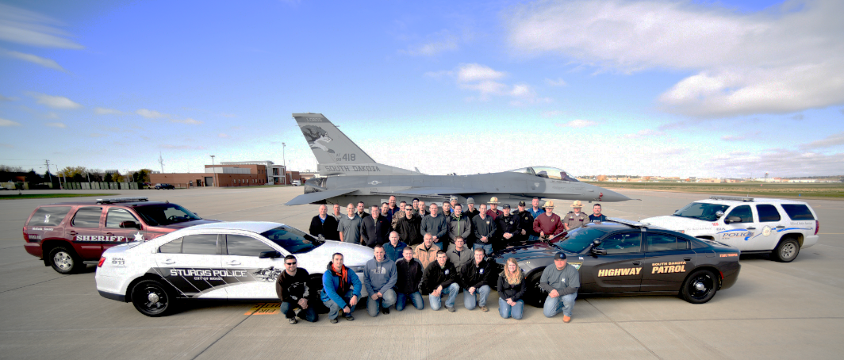

**“I’ve been to several interdiction classes and this, by far, blew those   
out of the water”** - Workshop Attendee

**Only $649 Per Student**when registered two-weeks prior to class **To Register:**visit ***www.DesertSnow.com***

or call **405-293-9800**

**Location:**Nashville, Tennessee (Area)

**Dates:**

August 9th-11th, 2022

(0800 to 1700) Doors open at 0730

**Attend The Nation’s Most Advanced & Comprehensive   
3 Day Hands-on Criminal Interdiction Workshop**

**Narcotics * Terrorism * Illicit Currency * Explosives * Weapons * Opioids**

**Training Address:**

City of Mufreesboro Airport

1930 Memorial Blvd.

Murfreesboro, TN 37129

**Host:**Desert Snow

POST Approved

**Host:**  
Tennessee Highway Patrol

POST Approved

**Workshop (8 hrs):**

* **Hands-On Searching Of Actual Vehicles**
  + **Car / Pickup / SUV / Van**
* **Exposure To Simulated IED’s**
* **Electronic Compartments Up Close & Personal**
* **Exposure To A Variety Of Simulated Contrabands**
* **Exposure To A Number Of Different Concealments**
  + **Tires**
  + **Engine Manifolds**
  + **Drivelines**
  + **False Batteries**
  + **Fuel Tanks & More**

**Classroom (16 hrs):**

* **Current Threats Facing Our Communities**
* **An “All Crimes” Approach To Criminal Interdiction**
* **Combating The Current Opioid Epidemic**
* **How To Conduct A Legal & Systematic Traffic Stop**
* **The Mindset Of A Contraband Smuggler**
* **Steps Taken By Criminals To Avoid Detection**
* **Recognizing Indicators Of Criminal Activity**
* **Pertinent Case Law Relating To Criminal Interdiction**
* **How Defense Attorneys Beat Criminal Cases In Court**
* **Developing Roadside Conversational Skills**
* **Spotting Deceptive Behavior**
* **How and When To Ask For Consent To Search**
* **Officer Safety Issues Pertaining To Interdiction**
* **Identifying Common Vehicle Concealments**
* **Numerous Electronic Compartment Videos**
* **Appropriate Asset Forfeiture Practices**
* **Post Arrest Considerations**
* **Current & Effective Interdiction Resources**
* **Numerous Recent Interdiction Traffic Stop Videos**
* **Review Of Numerous Recent Concealment Videos**

